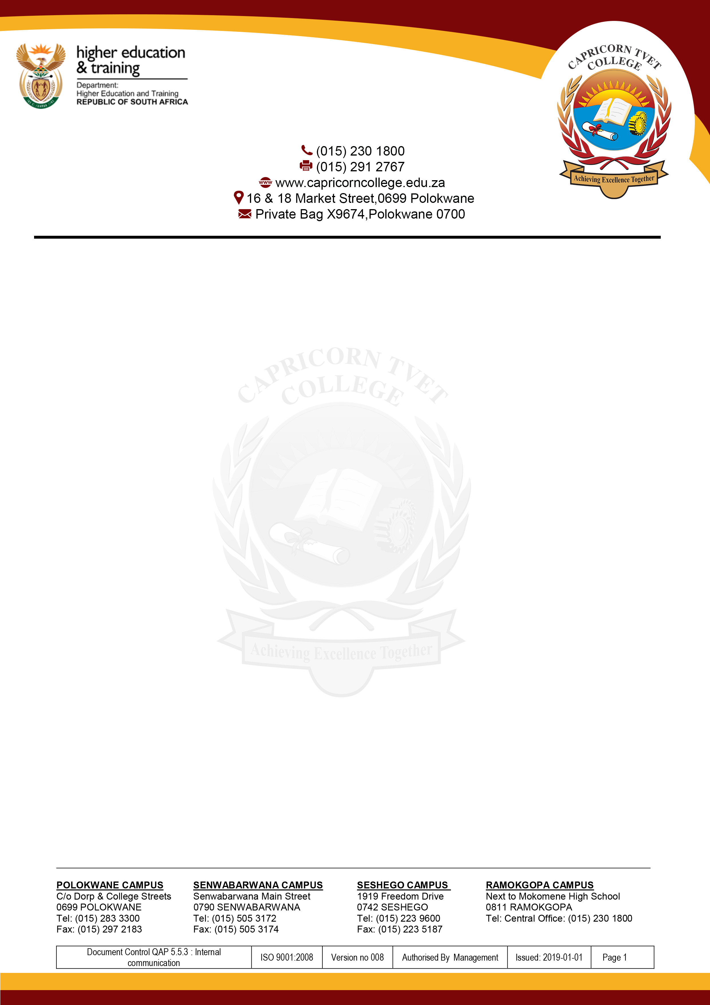
CAPRICORN TVET COLLEGE
CENTRAL OFFICE

APPLICATION FORM
2022 GRADUATION CEREMONY

SPECIAL INSTRUCTIONS

- To be completed by students who obtained National N Diploma or NC(V) Level 4 Certificate ONLY.
- The form must be typed in by the graduand and returned via email or to Central Office Examination Section.
- The completed form must be emailed to graduations@capricorncollege.edu.za ONLY.
- A Certified copy of National N Diploma or NC(V) Certificate Level 4 by SAPS must be attached.
- A Certified copy of ID by SAPS must be attached.
- The dates of the Graduation Ceremony are as follows: (03 to 07 October 2022)
- The closing date for submission of Application Forms for 2022 Graduation Ceremony is 12 August 2022.

SURNAME
FULLNAMES
(as appears on the diploma or certificate)
IDENTITY NUMBER

GENDER
(Male / Female)
PHYSICAL DISABILITY
(Yes / No)
CELLPHONE NUMBER |  | ALTERNATIVE CELLPHONE NUMBER
EMAIL ADDRESS |  | ALTERNATIVE EMAIL ADDRESS
CAMPUS
YEAR COMPLETED
PROGRAMME
SUBJECTS WITH DISTINCTIONS (80% - 100%)
NB. Only Level 4 and N4 to N6
Subjects

FOR OFFICE USE ONLY
DECLARATION: I hereby declare that the candidate met with the applicable requirements and has complied for the award of the diploma/certificate; and that the appropriate documents were received, verified and taken to my satisfaction.

SIGNATURE……………………………………………………………. DATE:………………………………………………………………

